
CENTRAL BOARD OF SECONDARY EDUCATION


JAWAHAR NAVODAYA VIDYALAYA
TARIKHET ALMORA UTTARAKHAND 263663

COMPUTER SCIENCE (083)
PROJECT FILE
On
CSV-BASED STUDENT MANAGEMENT SYSTEM
SUBMITTED BY :

S. No | Name | CBSE Roll
CLASS :
SECTION :

PRINCIPAL
(NAME OF PRINCIPAL)

INTERNAL EXAMINER
(TEACHER NAME)

EXTERNAL EXAMINER

ACKNOWLEDGEMENT

I wish to express my deep sense of gratitude and indebtedness to our learned teacher Pankaj Bhilingwal, PGT Computer Science, J.N.V Tarikhet Almora for his invaluable help, advice and guidance in the preparation of this project file.
I am also greatly indebted to our principal D.S Rawat and school authorities for providing me with the facilities and requisite laboratory conditions for making this project file.
I also extend my thanks to a number of teachers, my classmates and friends who helped me to complete this project file successfully.
NAME :

S. No | Name | CBSE Roll

CLASS : XII
SECTION : SCIENCE

CERTIFICATE

This is to certify that,
S. No | Name | CBSE Roll

Student of Class XII, J.N.V Tarikhet Almora has completed the PROJECT FILE during the academic year 2026-27 towards partial fulfilment of credit for the Computer Science Project evaluation of CBSE and submitted satisfactory report, as compiled in the following pages, under my supervision.

Internal Examiner External Examiner
Signature Signature

PREFACE

In the field of Computer Science, the term PROJECT refers to a Computerization Work that is completely performed by using a computer. Today when every field is going to be computerized means that all task of any field now a days done by using computer and their appropriate computer programs, then to do every field’s different-different works, today different programs or software’s are available in the form of Project.
Learning Python in schools is a part of our syllabus, and according to the syllabus worked out by the CBSE, to which my school is affiliated, I enjoyed doing project work for the session 2026-27. I learned a lot, especially learning by doing was a great experience. The report is a summary of what I observed and learnt in school. My humble thanks are going to all the concerned related to my project.
I also feel that it is the right time to thank my teacher, who guided me during my project. I also feel that it is the right time to thank my parents, friends and my project partners for their constant assistance, cooperation extended by them time to time.

INDEX
Table of Contents
About Project 5
Student Management System 5
Project Overview 5
Technology Stack 5
How to Run the Program 5
Flow Chart 6
Project Code 7
Output 12
Technological requirements: Hardware & Software 15
References 16

About Project

Student Management System
The Student Management System is a simple yet powerful program designed to facilitate the management of student records in an educational institution. This project is implemented in Python, a versatile and widely-used programming language, making it accessible and easy to maintain.

Project Overview
Objective:
The primary objective of the Student Management System is to provide a user-friendly interface for administrators to perform essential tasks such as adding, updating, deleting, searching, and displaying student records. This system offers a streamlined approach to managing student information, promoting efficiency and organization in academic record-keeping.
Key Features:
- Add Student: Enables the addition of new student records with essential details like admission number, name, course, fees, and date of birth.
- Update Student: Allows administrators to modify existing student information, ensuring accurate and up-to-date records.
- Delete Student: Provides the capability to remove student records, maintaining a clean and relevant database.
- Search Student: Facilitates quick and easy retrieval of student details based on their admission number.
- Display Students: Presents a comprehensive list of all students enrolled, aiding in overall data visualization.

Technology Stack
Programming Language: Python
Modules Used: csv, os
Description:
The project utilizes Python's simplicity and readability to implement the core functionalities of the Student Management System. The csv module is employed for handling CSV files, ensuring data persistence, and the os module assists in file and path operations.

How to Run the Program
- Clone the project repository.
- Ensure Python is installed on your system.
- Execute the main program file, and a menu-driven interface will guide you through various operations.
This Student Management System serves as a valuable tool for educational institutions to manage student data efficiently, contributing to enhanced administrative processes and improved data accuracy.

Flow Chart
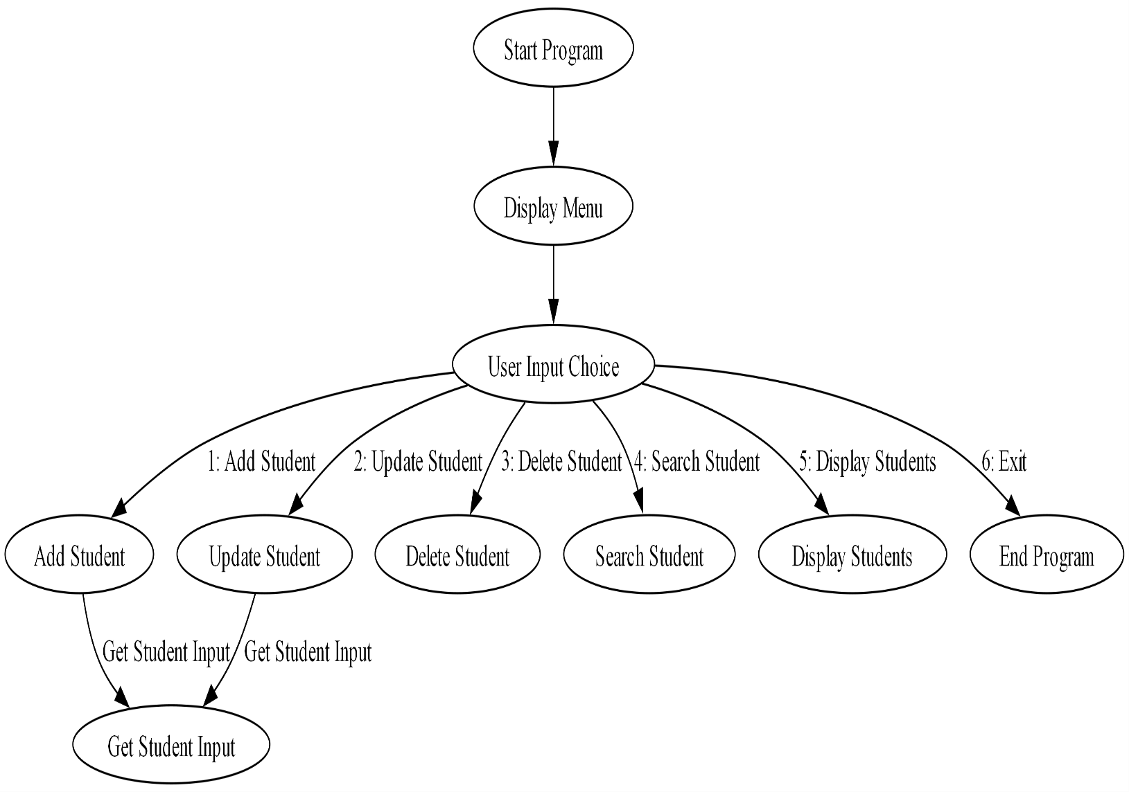

Project Code
import csv
import os

DATA_FILE = "student_data.csv"

def display_menu():
print("1. Add Student")
print("2. Update Student")
print("3. Delete Student")
print("4. Search Student")
print("5. Display Students")
print("6. Exit")

def add_student(admno, name, course, fees, dob):
with open(DATA_FILE, mode='a', newline='') as file:
csv.writer(file).writerow([admno, name, course, fees, dob])
print("Student added successfully!")

def update_student(admno, name, course, fees, dob):
data = load_from_file()
found = False

for i, row in enumerate(data):
if row[0] == str(admno):
data[i] = [str(admno), name, course, str(fees), dob]
found = True
break

if found:
write_to_file(data)
print("Student updated successfully!")
else:
print("No student found with Admission Number:", admno)

def delete_student(admno):
data = load_from_file()
found = False

for i, row in enumerate(data):
if row[0] == str(admno):
del data[i]
found = True
break

if found:
write_to_file(data)
print("Student deleted successfully!")
else:
print("No student found with Admission Number:", admno)

def search_student(admno):
data = load_from_file()
student = next((row for row in data if row[0] == str(admno)), None)
if student:
print_student_details(student)
else:
print("No student found with Admission Number:", admno)

def display_students():
data = load_from_file()
if data:
print("List of Students:")
print("--------------------------")
for row in data:
print_student_details(row)
else:
print("No students found.")

def print_student_details(student):
admno, name, course, fees, dob = student
print(f"Admission Number: {admno}")
print(f"Name: {name}")
print(f"Course: {course}")
print(f"Fees: {fees}")
print(f"Date of Birth: {dob}")
print("--------------------------")

def load_from_file():
data = []
if os.path.exists(DATA_FILE):
with open(DATA_FILE, "r") as file:
csv_reader = csv.reader(file)
data = list(csv_reader)
return data

def write_to_file(data):
with open(DATA_FILE, "w", newline='') as file:
csv.writer(file).writerows(data)

def main():
while True:
display_menu()
choice = int(input("Enter your choice: "))

if choice == 1:
admno, name, course, fees, dob = get_student_input()
add_student(admno, name, course, fees, dob)

elif choice == 2:
admno, name, course, fees, dob = get_student_input()
update_student(admno, name, course, fees, dob)

elif choice == 3:
admno = int(input("Enter Admission Number of student to delete: "))
delete_student(admno)

elif choice == 4:
admno = input("Enter Admission Number of student to search: ")
search_student(admno)

elif choice == 5:
display_students()
elif choice == 6:
break
else:
print("Invalid choice! Please try again.")

def get_student_input():
admno = int(input("Enter Admission Number: "))
name = input("Enter Name: ")
course = input("Enter Course: ")
fees = float(input("Enter Fees: "))
dob = input("Enter Date of Birth (YYYY-MM-DD): ")
return admno, name, course, fees, dob

if __name__ == "__main__":
main()

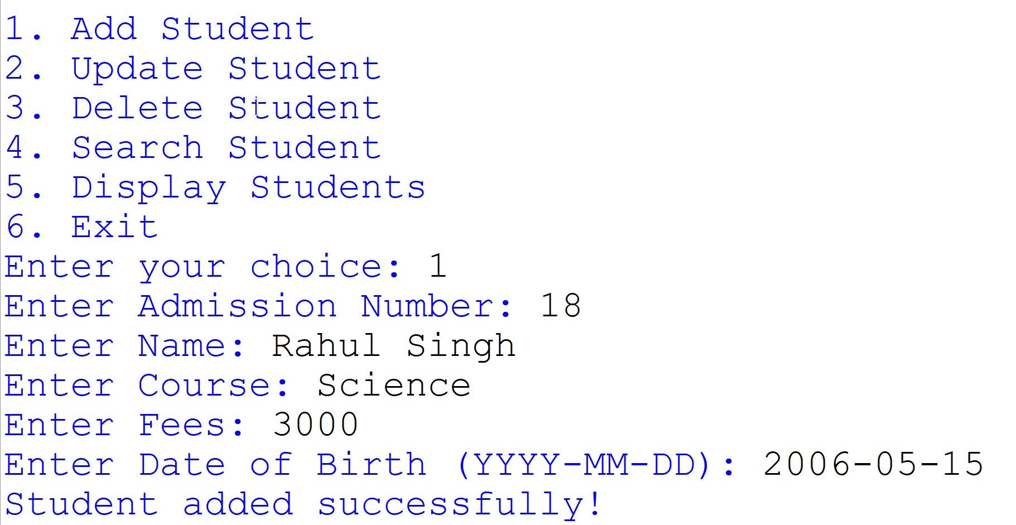
Output
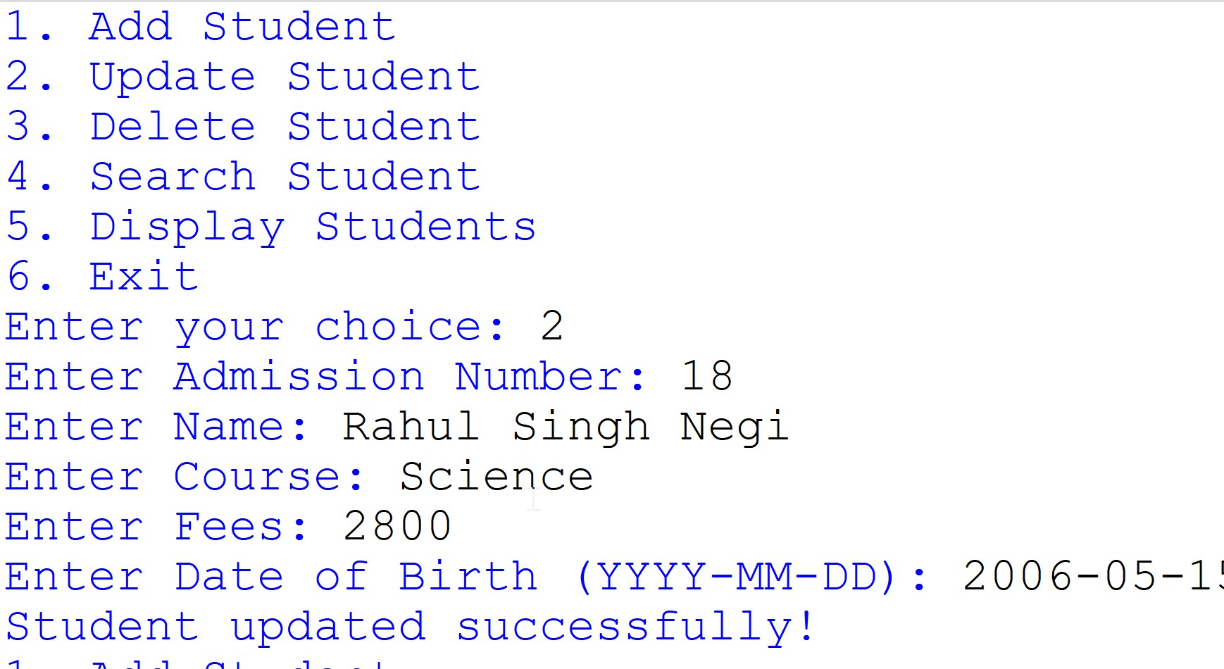

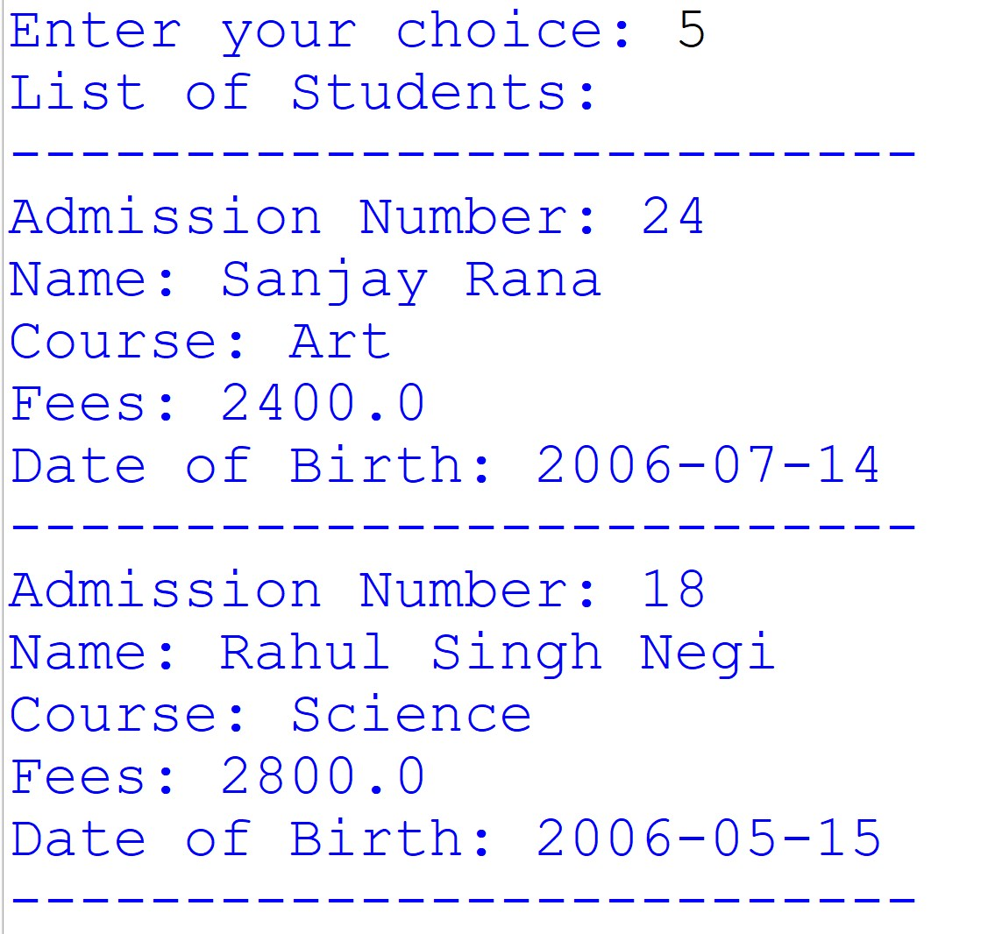

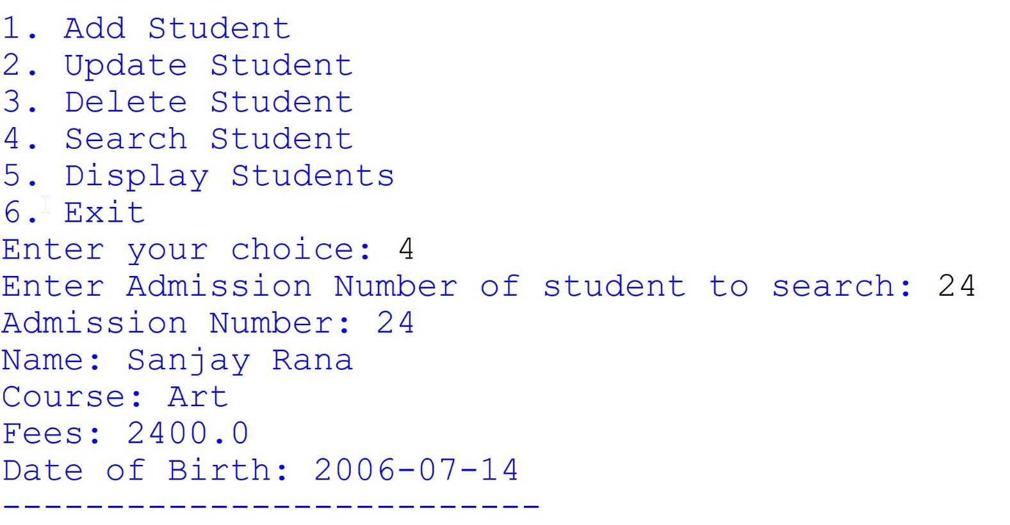
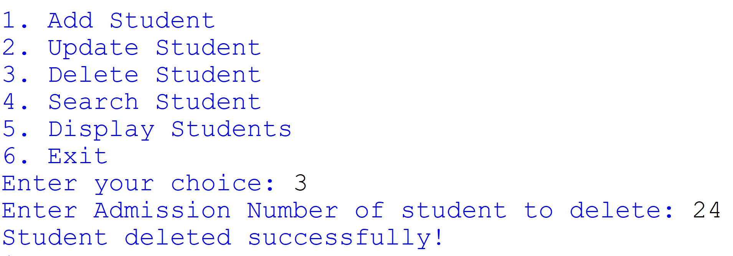

Technological requirements: Hardware & Software

Software
- Python
- VS Code
- Microsoft-Excel

Hardware
- Laptop/PC

References

- https://www.python.org/
- https://realpython.com/python-csv/
- https://www.programiz.com/python-programming/csv

